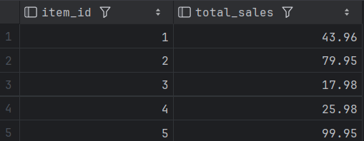

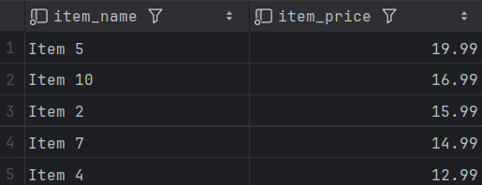
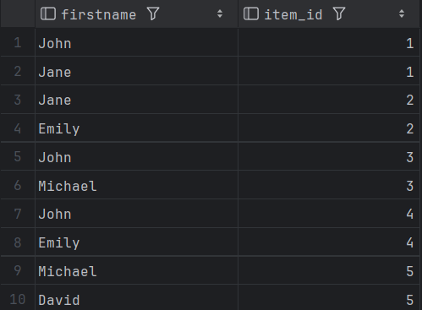
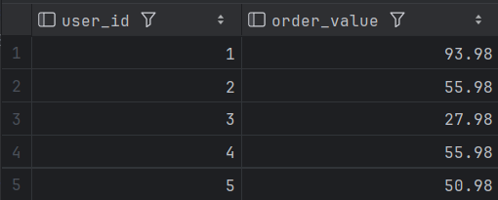
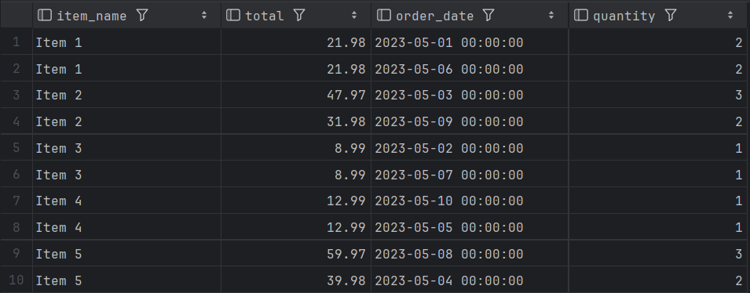
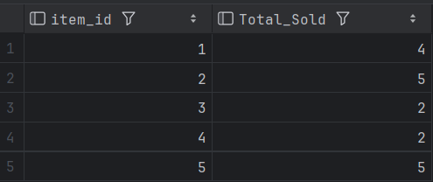
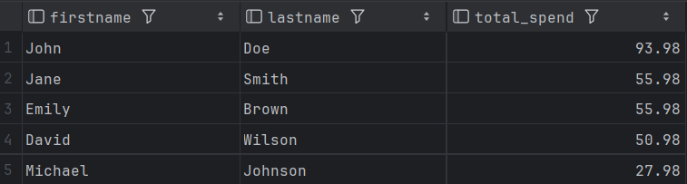
Week04 – SQL - QUESTIONS
These questions and queries cover a wide range of scenarios commonly encountered in a MKTIME database, utilising joins, subqueries, and aggregate functions to extract meaningful output from the database.
1. List all products.

Code | Expected Answer | Actual Answer
SELECT * FROM view_items | How many records you expect to display: 10 | 10 rows

2. Find the total sales amount for each product.
SELECT item_id, SUM(total) AS total_sales
FROM view_orders
GROUP BY item_id;

3. List all users who made purchase on 3rd May 2023.
SELECT user_id, order_date
FROM view_orders
WHERE order_date = '2023-05-03';

4. Find the top 5 costing items.
SELECT item_name, item_price
FROM view_items
ORDER BY item_price DESC
LIMIT 5

5. List all items and who purchased those items.
SELECT u.firstname, o.item_id
FROM view_orders o, view_users u
WHERE o.user_id = u.user_id
ORDER BY o.item_id ASC

6. Find the total order value for each user.
SELECT user_id, SUM(payment_amount) AS order_value
FROM view_payment
GROUP BY user_id;

7. List all products with their corresponding orders.
SELECT i.item_name, o.total, o.order_date, o.quantity
FROM view_orders o, view_items i
WHERE i.item_id = o.item_id
ORDER BY i.item_name;

8. Find the customer who spent the most in total.
SELECT u.firstname, u.lastname, SUM(payment_amount) as total_spend
FROM view_payment p, view_users u
WHERE u.user_id = p.user_id
GROUP BY p.user_id
ORDER BY total_spend DESC
LIMIT 1

9. Find the top 3 categories with the highest total sales.
None given

11. List all orders made by a specific customer (e.g., John Doe).
SELECT *
FROM view_orders
WHERE user_id = 1

- Find the number of orders placed by user_id = 2.
SELECT *
FROM view_orders
WHERE user_id = 2

13. List all items with their respective quantities sold.
SELECT item_id, SUM(quantity) as Total_Sold
FROM view_orders
GROUP BY item_id

14. Find the total sales made by each user.
SELECT u.firstname, u.lastname, SUM(payment_amount) as total_spend
FROM view_payment p, view_users u
WHERE u.user_id = p.user_id
GROUP BY p.user_id
ORDER BY total_spend DESC

